[The Problems of Art Criticism](https://mymoodle.sampsoncc.edu/mod/resource/view.php?id=235590" \o "The Problems of Art Criticism)**,**

**Frida Kahlo & Auguste Rodin**

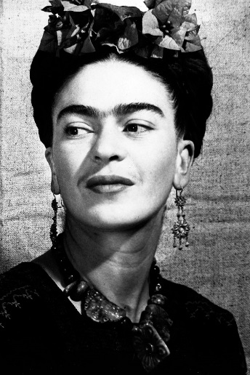

"I never paint dreams or nightmares. I paint my own reality."- Frida Kahlo

**RIGHT CLICK THE LINK BELOW & OPEN IN NEW TAB**

This is the story of the artist Frida Kahlo. She was quite a risque lady who's artwork was seemingly strange, but perfect for what she was trying to say. Her life was quite interesting... full of ups and downs. Even though she was female, she is just as shocking as some of her male colleagues. The video biography was produced by high schoolers, so a bit of the information is "off" however, they got all of the "big stuff" correct! I think this little video is humorous... and a good platform for you to decide if you want to do more research about Frida. (15 mins)

***********************************************************************************************************

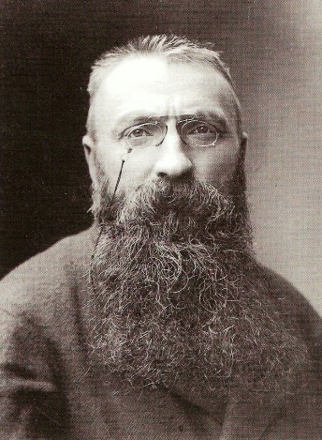  
"To the artist  there is never anything ugly in nature."- Auguste Rodin

**RIGHT CLICK  & OPEN IN NEW TAB**

[**http://www.dailymotion.com/video/x1gbuou_biography-of-auguste-rodin-discovery-history-art-documentary_creation**](http://www.dailymotion.com/video/x1gbuou_biography-of-auguste-rodin-discovery-history-art-documentary_creation)

This Video highlights the artist Auguste Rodin. He was an extremely famous sculptor. Some of his sculptures are actually on display at the North Carolina Museum Of Art. One of Rodin's most famous & controversial works was "The Kiss". At first glance you are going to wonder what direction the class is going! However, put on your grown up pants and learn to appreciate this sculpture for what it is.... absolute beauty. Some of you may get a giggle, many of you will see it's grandeur... but in the end you should realize what exactly you are looking at: One of the most famous sculptures of all time! (48 mins)

I must warn you... there is NUDITY (it is everywhere in art!) and reference to "naughty" things. Try your best to keep it together. You probably do not want to watch this in public or around small children.

If you start the movie and find it offensive, you do not have to watch it. There will be questions from the video on your exam, but there will not be enough of them to KILL your grade if you study every thing else.

************************************************************************************************************

***The 4 Stages of Art Criticism***

**RIGHT CLICK & OPEN IN NEW TAB**

This is a short 3 minute video of random people Critiquing a piece of art by the Street Artist named "Banksy". You will notice that they are NOT using the "4 stages of Art Criticism" simply because, "everyday people" don't go through the Formal Process.... The video will give you some insight on how you critique things all the time, and you don't even realize it!.... but yes, you do need to at least know what the 4 Stages are, so Please look at the power point!--- There will be questions on the Exam! smile

************************************************************************************************************

**You will be asked to complete a discussion forum on this topic.**

**\*Please be respectful of others and be mindful when making posts about this videos!\***

**Be sure to look at the powerpoint below!**

**You will need it for the forum and your Exam. smile**